|  |  |
| --- | --- |
|  |  |
|  |

|  |
| --- |
| **Lab 10: Working with JOINs** |

**Objective(s):**

1. Introduction of JOIN
2. INNER JON
3. LEFT JOIN
4. RIGHT JOIN
5. CROSS JOIN
6. STRAIGHT JOIN
7. NATURAL JOIN
8. EQUI JOIN
9. NON EQUI JOIN
10. SELF JOIN

|  |
| --- |
| **1: Introduction of JOIN** |

A relational database consists of multiple related tables linking together using common columns which are known as foreign key columns. Because of this, data in each table is incomplete from the business perspective.

By using joins, you can retrieve data from two or more tables based on logical relationships between the tables. Joins indicate how SQL should use data from one table to select the rows in another table.

A join condition defines the way two tables are related in a query by:

* Specifying the column from each table to be used for the join. A typical join condition specifies a foreign key from one table and its associated key in the other table.
* Specifying a logical operator (for example, = or <>,) to be used in comparing values from the columns.

There are various forms of the JOIN clause. These will include:

1. INNER JOIN
2. OUTER JOIN (both LEFT and RIGHT)
3. FULL OUTER JOIN
4. CROSS JOIN

A JOIN does just what it sounds like—it puts the information from two tables together into one result set. We can think of a result set as being a “virtual” table. It has both columns and rows, and the columns have data types. How exactly does a JOIN put the information from two tables into a single result set? Well, that depends on how you tell it to put the data together—that’s why there are four different kinds of JOINs. The thing that all JOINs have in common is that they match one record up with one or more other records to make a record that is a superset created by the combined columns of both records.

**For example** we have the orders and orderdetails tables that are linked using the orderNumber column:

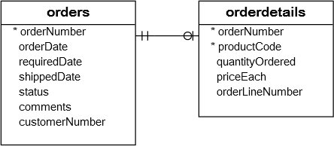

To get complete orders information, you need to query data from both orders and orderdetails tables. That’s why joins come into play.

A join is a method of linking data between one (self-join) or more tables based on values of the common column between the tables.

|  |
| --- |
| **2: INNER JOIN/JOIN** |

The INNER JOIN keyword selects records that have matching values in both tables.

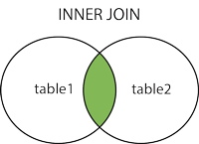

**Syntax:**

|  |
| --- |
| SELECT column_name(s) FROM table1 INNER JOIN table2ON table1.column_name = table2.column_name; |

If the join condition uses the equal operator (=) and the column names in both tables used for matching are the same, you can use the USING clause instead:

**Syntax:**

|  |
| --- |
| SELECT column_name(s) FROM table1 INNER JOIN table2USING(column_name); |

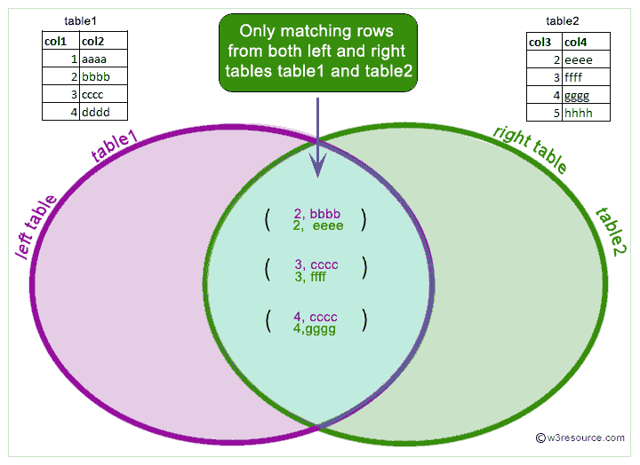

|  |
| --- |
| **3: LEFT JOIN** |

The LEFT JOIN keyword returns all records from the left table (table1), and the matched records from the right table (table2). The result is NULL from the right side, if there is no match.

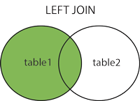

**Syntax:**

|  |
| --- |
| SELECT column_name(s) FROM table1 LEFT JOIN table2ON table1.column_name = table2.column_name; |

|  |
| --- |
| Note: In some databases LEFT JOIN is called LEFT OUTER JOIN. |

|  |
| --- |
| **4: RIGHT JOIN** |

The RIGHT JOIN keyword returns all records from the right table (table2), and the matched records from the left table (table1). The result is NULL from the left side, when there is no match. 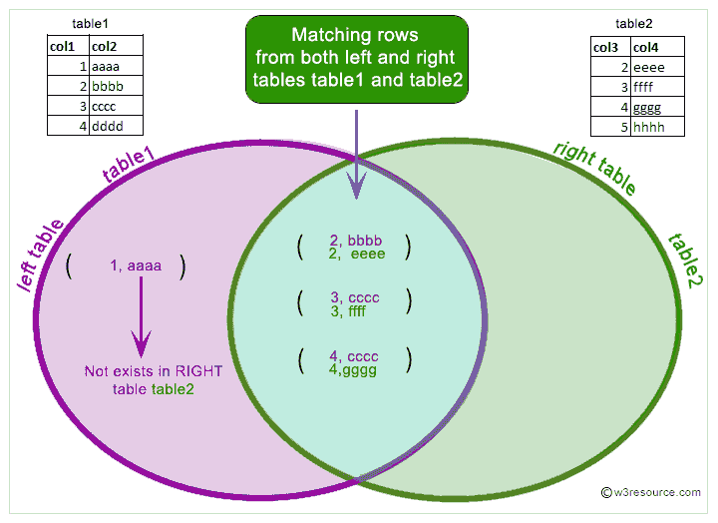

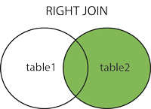

**Syntax:**

|  |
| --- |
| SELECT column_name(s) FROM table1 RIGHT JOIN table2ON table1.column_name = table2.column_name; |

|  |
| --- |
| Note: In some databases RIGHT JOIN is called RIGHT OUTER JOIN. |

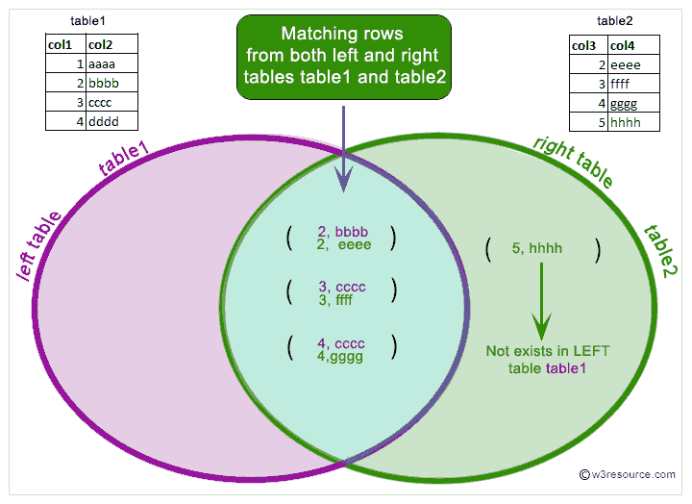

|  |
| --- |
| **5: CROSS JOIN** |

In MySQL, the CROSS JOIN produced a result set which is the product of rows of two associated tables when no WHERE clause is used with CROSS JOIN.

In this join, the result set appeared by multiplying each row of the first table with all rows in the second table if no condition introduced with CROSS JOIN.

This kind of result is called as Cartesian Product.

In MySQL, the CROSS JOIN behaves like JOIN and INNER JOIN without using any condition.

In standard SQL the difference between INNER JOIN and CROSS JOIN is ON clause can be used with INNER JOIN on the other hand ON clause can't be used with CROSS JOIN.

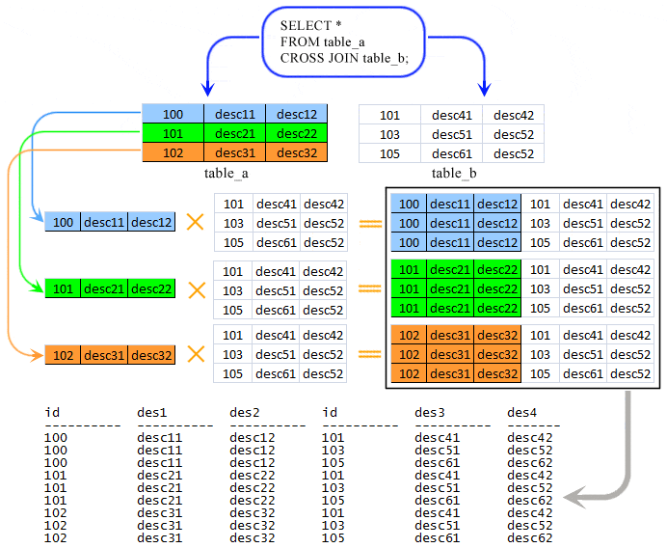

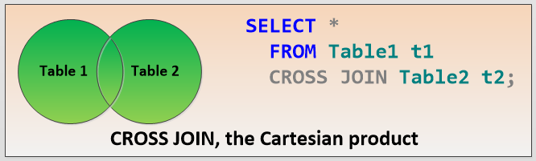

**Syntax:**

|  |
| --- |
| SELECT table1.col1, table2.col1, table1.col2, table2.col3, …  FROM table1  CROSS JOIN table2; |

**Lab Task(s):**

Exercise

1. Write a query in SQL to display the first name, last name, department number, and department name for each employee. (**Sample tables:** employees & departments)
2. Write a query to find the name (first_name, last_name), job, department ID and name of the department who works in London. (**Sample tables:** employees , locations & departments)
3. Write a query in SQL to display the first and last name, department, city, and state province for each employee. (**Sample tables:** employees , locations & departments)
4. Write a query to find the employee id, name (last_name) along with their manager_id and name (last_name). (**Sample tables:** employees)
5. Write a query to find the name (first_name, last_name) and hire date of the employees who was hired after 'Jones'. (**Sample tables:** employees)
6. Write a query to get the department name and number of employees in the department. (**Sample tables:** employees & departments)
7. Write a query to display the department ID and name and first name of manager. (**Sample tables:** employees & departments)
8. Write a query to display the department name, manager name, and city. (**Sample tables:** employees , locations & departments)
9. Write a query to display the job history that were done by any employee who is currently drawing more than 10000 of salary. (**Sample tables:** employees & job_history)
10. Write a query to display the first name, last name, hire date, salary of the manager for all managers whose experience is more than 15 years. (**Sample tables:** employees & departments)
11. Write a query in SQL to display the name of the department, average salary and number of employees working in that department who got commission. (**Sample tables:** employees & departments)
12. Write a query in SQL to display the name of the country, city, and the departments which are running there. (**Sample tables:** countries , locations & departments)
13. Write a query in SQL to display department name and the full name (first and last name) of the manager. (**Sample tables:** employees & departments)
14. Write a query in SQL to display the details of jobs which was done by any of the employees who is presently earning a salary on and above 12000. (**Sample tables:** employees & job_history)
15. Write a query in SQL to display the full name (first and last name), and salary of those employees who working in any department located in London. (**Sample tables:** employees , locations & departments)
16. Write a query to display job title, employee name, and the difference between salary of the employee and minimum salary for the job. (**Sample tables:** employees & jobs)
17. Write a query to display the job title and average salary of employees. (**Sample tables:** employees & jobs)
18. Write a query to find the employee ID, job title, number of days between ending date and starting date for all jobs in department 90 from job history. (**Sample tables:** jobs & job_history)

**END**